# Macintosh HD:Users:razor:Documents:_OriginCaseStudy:evolve_media_corp_origin_logotype_r02a.jpg

## Overview

‘Origin is a stepping stone to what we can do’

Origin is a rich media ad creation and publishing suite. Custom built internally, it serves as our central hub that showcases our product line, intuitive ad creator and seamless demo creation tool.

## Statistics

Origin has currently served over 150 million ad impressions per year, generating over $5 million in saved expenses and collected serving fees. It is highly scalable, compatible with the multitude of site layouts in our network, as well as also being able to serve on Desktop, Tablet and Mobile platforms independently.

## Technology

Origin’s foundations are built upon the CakePHP framework, with a MySQL database. The UI is a mixture of HTML5/CSS3 and Javascript libraries and frameworks such as jQuery/jQuery UI and Google’s AngularJS framework.

# Branding



*origin (n) – something from which anything arises or is derived; source; fountainhead*

The name for the platform was derived from the theory that all ad units can share a common ancestor. The Origin brand unifies everything from the company’s name to the platform’s product line.

## Mission & Values

* We want people to respond to the brand with curiosity
* Trendsetting, limitless, adaptive and innovative
* Our products are better at *everything*.

## Design Influences

The ‘Origin’ is also a reflection of the company name, Evolve Media, LLC., with Darwin’s *Origin of Species*. This DNA flows throughout the brand.

~~Origin ad units share a lineage of using astronomical terms for their template names that also describe the unit and it’s effects.~~

* ~~Eclipse –~~ *~~any obscuration of light~~* ~~- An in-page ad unit whose triggered expansion overlaps the initial ad unit state.~~
* ~~Horizon –~~ *~~the line that forms the boundary between earth and sky -~~* ~~A thin, full page width ad unit that sits above all content and expands.~~
* ~~Nova –~~ *~~an exploding star -~~* ~~An in-page ad unit that triggers an overlay state.~~

|  |  |
| --- | --- |
| ttp://static.guim.co.uk/sys-images/Guardian/Pix/pictures/2008/04/17/DarwinSketch.article.jpg  *Darwin’s Tree of Life* | ttp://upload.wikimedia.org/wikipedia/commons/thumb/1/12/CollapsedtreeLabels-simplified.svg/500px-CollapsedtreeLabels-simplified.svg.png  *A modern day phylogenetic tree,*  *where a species’ origins can be charted.* |

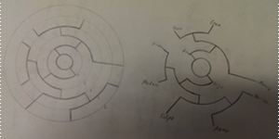

*Origin’s product ‘tree’. Contains the initial product lineup*

*and accurately associates its children and ancestors.*

For our logo icon, we needed it to be simple and abstract. The circle motif is associated with our platform so we started there. Playing upon simplifying the product tree, we noticed that it was possible to integrate in the logo type into an abstract design.

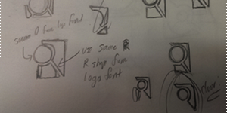

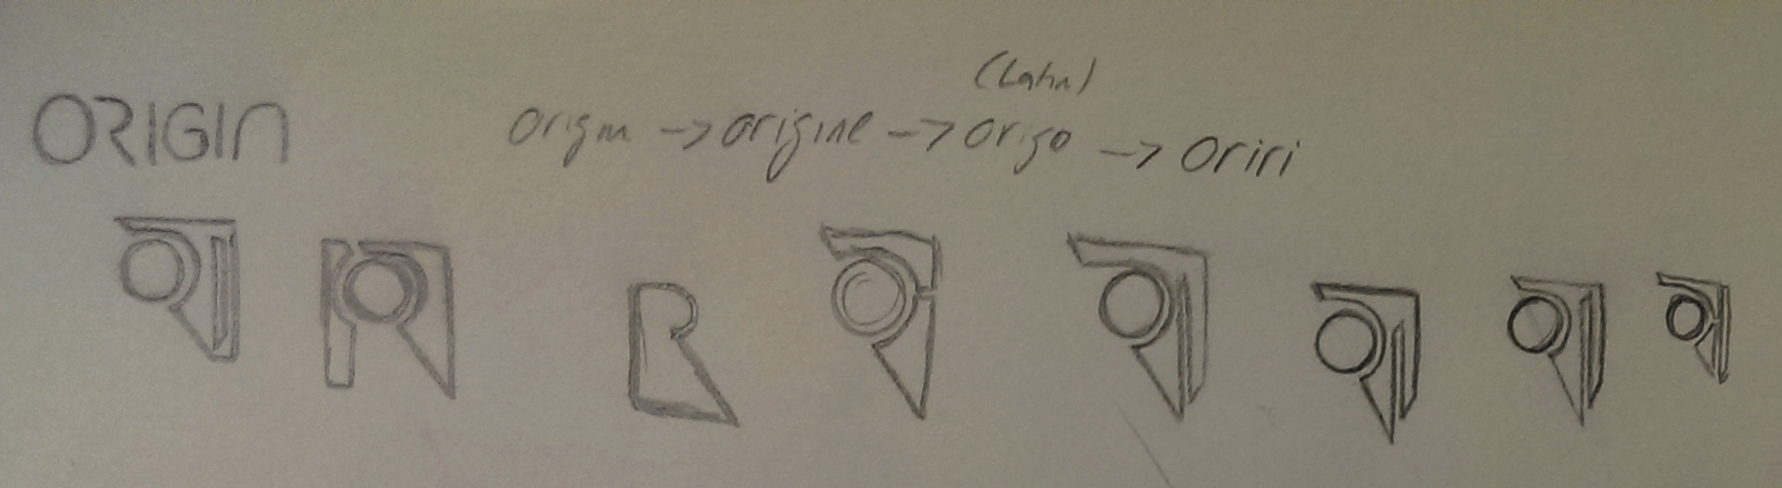

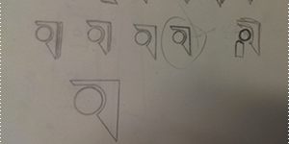

We’ve arrived at the selected design. The most prominent is the callback to the unique ‘R’ typeface from the logo type, as well as the ‘I’, integrated in to look like a shadow. It also retains a simplified version of the phylogenetic tree, with the two main branches from the point of origin.



# Origin Ad Creator

## Overview

The ad creator is the core application of the Origin platform. This is the nexus where all aspects of the platform meet. From here, we can create, edit, manage and deliver our online ad product line.

## UI/UX Workflow

Origin’s interface started out with sketches. Even though high resolution screens were the primary platform for Origin, steps were taken to also make it usable on tablets.

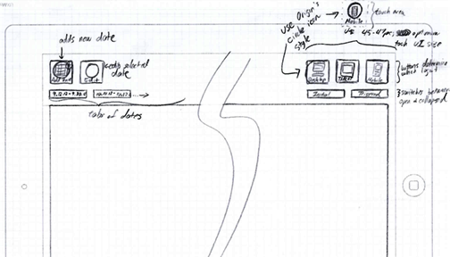

*One of the earliest layout concept for the ad creator – Trying out iconography for the UI*

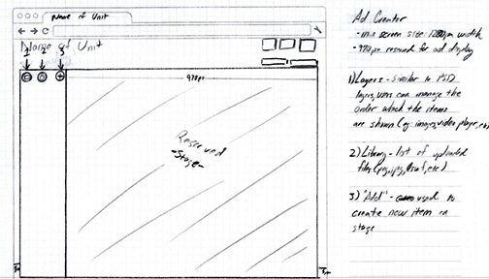

*Refinement of the first concept layout – Isolating more of the UI towards one side to optimize workflow UX*

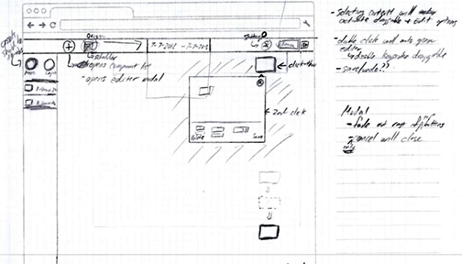

*Selected concept layout – Emphasizes a full-screen, responsive , touch-optimized placements and*

*modal windows for efficient workspace usage*

## Final Product

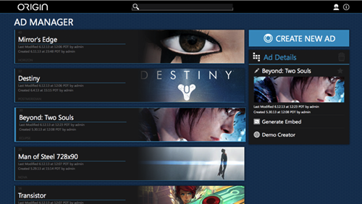

*The ad manager layout showcases large, beautiful creatives to easily identify each project.*

*On the right, we have easy access to the ‘Generate Embed’ and ‘Demo Creator’ functions of Origin*

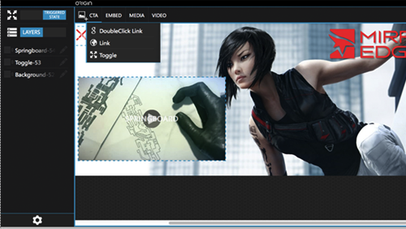

*Origin’s ad creator – While users have access to a wide breath and*

*depth of options, the interface is still very clean and simple.*

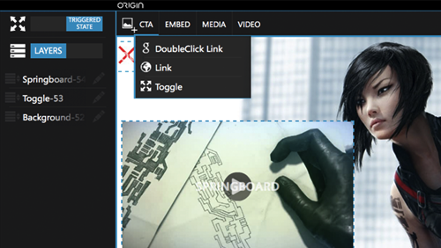

*Grouping the various components into dropdowns helps minimize interface clutter*

*and streamlines the amount of information that can be shown*

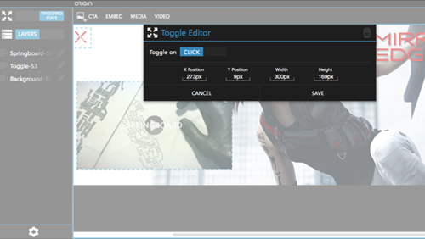

*Utilizing a modal window for the component’s editor provides the most flexibility in terms of screen estate*

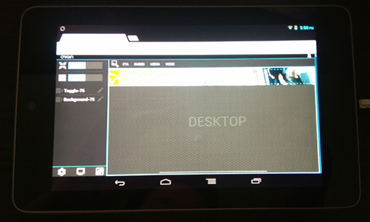

*Origin Ad Creator on a Nexus 7 tablet – Consideration was taken to*

*ensure an usable experience on touch devices*

*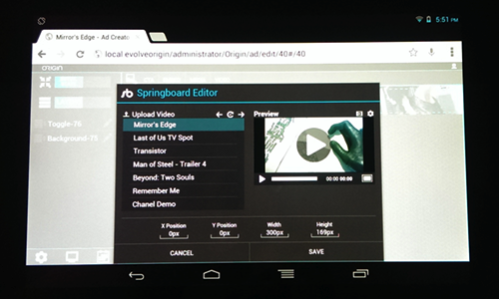*

*Workflow is the same on a touch device*

# Origin Ad Preview

## Overview

We approached Origin’s Ad Preview with the intention that these should properly showcase an ad unit in its proper environment.

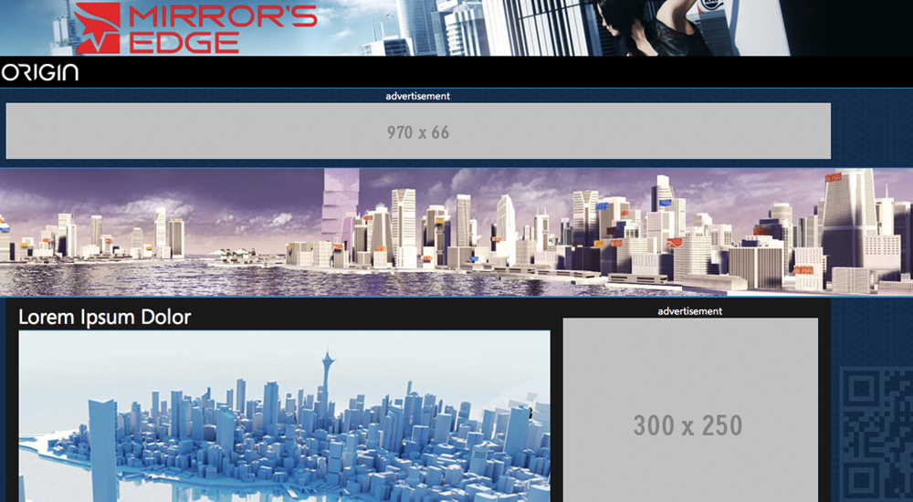

*A QR code is also generated and watermarked on each page to easily display it on mobile devices.*

In addition, we added support for all sites in our network. Users also have the ability to define the location where the ad unit will be rendered, as well as also define the preview page’s background image.

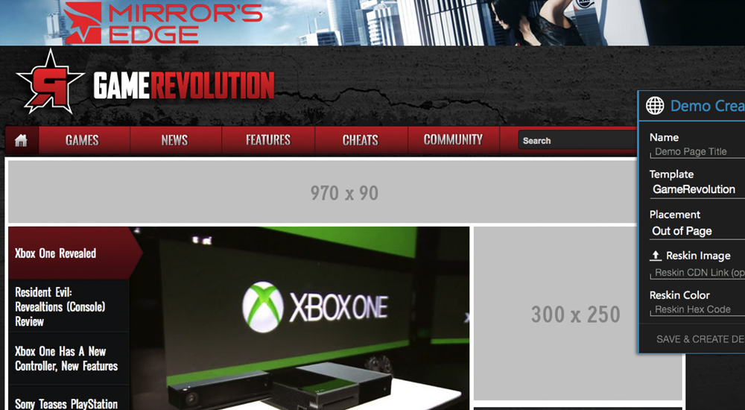

*GameRevolution – Part of the CraveOnline Media network*

## Technology

Origin’s demo links utilize an encrypted and shortened URL. This permits a links to be easily sharable without exposing other demo pages with a seemingly random URL naming scheme.

The shortened URL is simply a hash of the demo page’s primary ID from the database. The hashing algorithm uses prime numbers approaching the golden ratio to give the impression of randomness and prevents data collision.

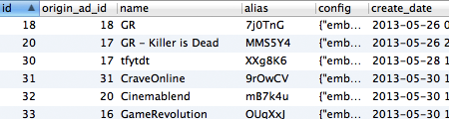

The demo page lookup overhead for the database has a time complexity of O(1), as each alias field is always unique.

# Origin Ad Units

## Overview

Origin ad units derive its templates and features from IAB ad units as well as custom in-house executions.

## Technology

### Rendering

### Deployment

Instead of the traditional method of creating the ad units directly into the DOM, we run them through iframes. Because we’re utilizing iframes, it allows us greater freedom in frameworks to use within the ad unit without affecting the parent site. Origin’s ad iframes are also loaded asynchronously, greatly improving page load times.

The asynchronous nature of the Origin ad embed code permits further optimizations. As all Origin ad units are generated from the same Javascript initialization code, we

only need to load the ad rendering Javascript file once on the page, and ignore additional

requests for the same file.